
Year 7 Number Mini Test
/42
Name: Date:
1 A4 page of handwritten notes is allowed
No Calculator
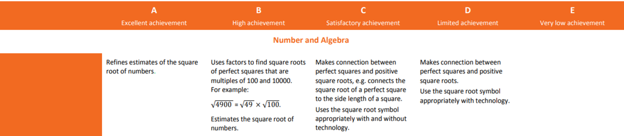

x | 1 | 2 | 3 | 4 | 5 | 6 | 7 | 8 | 9 | 10
1
2
3
4
5
6
7
8
9
10

Complete the table.
Question 1 (6 marks)

Index Form | Expanded Form
 | 2x2x2x2
 | 3x3x3x3x3x3x3x3
 | 10x10x10x10x10x10
5³

12⁵
4⁴

Evaluate the following squares and cubes by first expanding.
Question 2 (10 marks)

Index Form | Expanded Form | Evaluate
3²
10²
20²
3³
5³

Question 3 (3 marks)

Evaluate the following square roots
- $\sqrt{16}$

- $\sqrt{81}$

- $\sqrt{49}$

Evaluate the following cube roots.
Question 4 (3 marks)

- $\sqrt[3]{1}$

- $∛8$

- $∛125$

Question 5 (4 marks)
- List all the factors of 8. b) List all the factors of 45.

8 45

Question 6 6 marks

List all the factors for 16 and 36.

16 36

What is the lowest common factor? __________

What is the highest common factor?__________

Question 7 3 marks

Use a factor tree to find the prime factors of 30.

30

Complete the equation 30 = ___________________
Question 8 3 marks
Estimate the square root of 18.

Evaluate $√8100$.
Question 9 2 marks

Question 10 2 marks
If a square garden bed side length was increased by 1 m and the area of the new square garden bed is now 36m², what was the original side length?

End of test

